**Participants:** Hanna Blomfelt, Nord Pool Spot

Jan Owe, SvK

Jari Hirvonen, Fingrid

Jon-Egil Nordvik (Convenor)

Ole Fredsø Weigelt, Energinet.dk

**To:** Participants

Antti Niemi, Nord Pool Spot

Christian Hoang Huy Le, Statnett

Christian Odgaard, Energinet.dk

Jesper Gronlund, Fingrid

Ove Nesvik, EdiSys (Secretary)

Roar Grindstrand, Statnett

**CC:** Jan-Olov Lundberg, SvK

Oscar Ludwigs, SvK

Tor Bjarne Heiberg, Statnett

Tor Åge Halvorsen, NordPool

**Attachment:** None

1. Approval of agenda

The agenda was approved with the following additions:

* Proposal for NEMM47 from ENTSO-E, see *item 3, Maintenance requests to ENTSO-E*

1. Approval of previous meeting minutes

The minutes from previous meeting was approved with the following comments:

* Some links where not working, Ove will correct them.

1. Maintenance requests to ENTSO-E

*Homework from previous meeting:*

* Fedder is asked to get a status for NEMM2010/35 and NEMM2010/67

***Status:*** Both should be handled by ERRP.

* DK will go through and find a better justification for NEMM2010/48-51 and NEMM2011/86

***Status:*** DK will go through these codes for the next meeting and probably remove several of them. NEMM 86 was updated (see below).

* Hanna will submit a request for EIC code for the Nord Pool spot market area

***Status:*** Postponed

* Denmark (Christian) will find a GS1 code for NOIS.

***Status:*** Christian has made a GS1 ID = 5790001330576 for NOIS. The NOIS group will clarify the usage at their next meeting.

* Jon-Egil will ask Mike for the IG for the settlement process of RGCE, where different tariff types are used.

***Status:*** Postponed

Ove had made a MR, NEMM 2011/93, for addition of Corridor in the ECAN Capacity document. The MR was reviewed and will be added to the next bulk of MRs to ENTSO-E.

NEMM 2011/86 was reviewed with the following new proposal for the description:

**Z17** Technical minimum production including operation outside the normal operating range of the unit. I.e. “under loading” the unit.

**Z18** Technical maximum production including operation outside the normal operating range of the unit. I.e. overloading the unit.

Proposal for NEMM47 from ENTSO-E.: The proposal was reviewed and Jon-Egil will report back a change in the activity diagram, else it seemed to fit our needs. We don’t need a new process type for changes after cut-off, before settlement.

1. BRS for Schedules

Ove had as homework from previous meeting added NOIS rules in appendix A, similar to what is done in the BRS for Determine transfer capacity.

Changes to the document during the meeting:

* The text “*There is one single message identification per sender, delivery day, message type, process type and classification type (e.g. a TSO should transmit its entire interchange plan in a single message for a given delivery day).*” was removed from appendix A.
* The discussion related to arrow 6 in the sequence diagram for market schedules was continued:
  + The document (arrow) is not modelled in the Nordic Trading System.
  + Ole and Jan will check internally. It has probably something to do with matching procedures.

***Homework:***

* Ole and Jan will check internally the usage of arrow 6 in the sequence diagram for market schedules.
* Ove will update the document with comments made in the document during review.

1. BRS for Nordic trading system

*Homework from previous meeting:*

* Hanna will verify if we shall continue with the ERRP Allocation Result Document or change to ECAN (e.g. Allocation result) or make our own.

***Conclusion:*** Agreed to base our Spot market documents on ECAN.

* All will verify the use of ECAN and/or ERRP, including if we should propose an ERRP Auction specification document?

***Conclusion:*** Agreed to propose an ERRP auction specification document.

The unfinished processes and documents were gone through:

* Z28 and Z29 will be deleted and replaced with A01 and A04, NEMM 2011/64.
* Make a proposal for exchange rates based on the NOIS message, but adding standard headers.
* Ove checks the consequence of moving to ECAN allocation result for the Spot market.
* Ole checks if there is a need for a reference to the bid document in the activation document.
* “Split the *Time Interval element* into a *Start* and an *End* element, see maintenance request   
  NEMM 2010-3” should be removed from the whole document since it has been rejected in ENTSO-E
* A bid identity will be used to identify bids in the activation message in the future system of Sweden.

1. Review of draft BRS for Nordic settlement system (if a report form NBS is available)

A NBS report is expected in August. The item was postponed until next meeting.

1. ENTSO-E ERRP WG membership

Status for membership from the Nordic countries:

* From Statnett: Jon-Egil
* From Energinet.dk: Ole
* From SvK: probably none
* From Fingrid: TBD

1. Implementation verification

Do we have any tasks suitable for Implementation verification?

* Jan will propose NEMM xml for the SwePol link.
* Ole will check the possibility to move the Skagerrak exchange to Statnett to NEMM xml.
* Jari will check during summer.
* Nord Pool Spot is looking into it.

***Homework:***

* Jan, Ole, Jari and NPS will look for projects for Implementation verification

1. Information to "entsoe.net"

There was no new information related to entsoe.net.

1. CIM XML

Status and follow up if NEMM is going to do anything:

* ENTSO-E plan to change from PSSE to CIM-XML? Jari checks.
* Energinet.dk will send CIM-XML to RWE for DK1 in the foreseeable future.

***Homework:***

* Jari checks if ENTSO-E plan to change from PSSE to CIM-XML

1. Meteorological information

Status and follow up if NEMM is going to do anything:

***Homework:***

* Jari follows up on “CIM for meteorological data”

1. Review of project plan

Nothing will be done related to the operational phase for the time being.

The activation should probably be elaborated further. The item will be put on the next agenda.

1. Information (if any)

* NEG meetings
* ebIX®, EFET and ENTSO-E Harmonisation group meetings
* ebIX® Forum meeting
* NordREG Task Forces: Tor Heiberg has proposed to have NEG handle the NordREG message exchange.

1. Next meeting

* Wednesday August 31st and Thursday September 1st, Copenhagen
  + NBS should be invited to present their plans.

1. AOB

No items.

1. Trade in Swedish primary regulation from April 2011

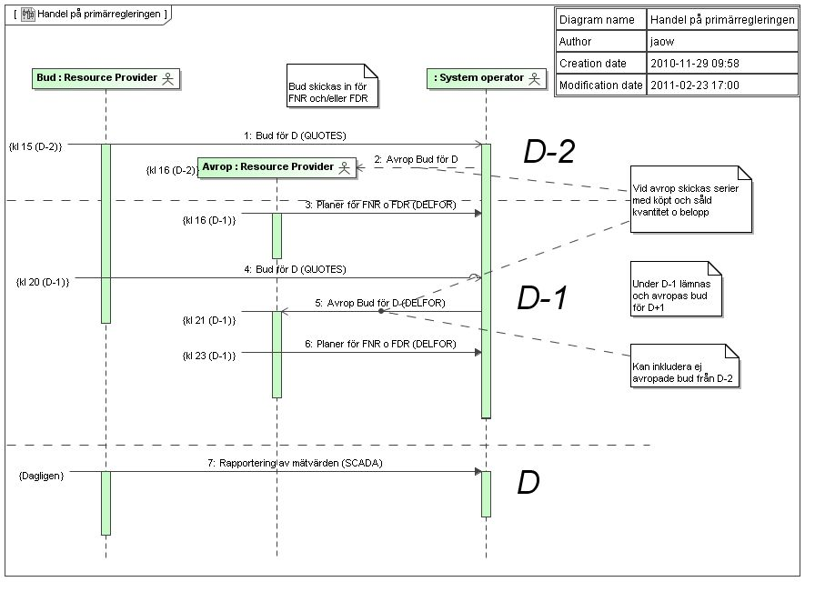

1. To be discussed and agreed
2. Should the new principles for time series identification in Sweden influence this project?
3. Follow up on *Special rules related to NOIS*:

* Reason codes have to be sent in a separate time series. The related quantities must always have a dummy value, but the value will be ignored by NOIS.

1. Follow up on question to the HG on how to handle a *Quantity quality* (metered, estimated…) and “*no-value*”or “*nill*”.
2. The operation name for submission of a message in WS should specifically not be named SendMessage since this exact name is used as a reserved keyword in Microsoft BizTalk Server. If, and if so where, to put this recommendation should be decided.
3. ENTSO-E maintenance requests related to Danish reason codes

|  |  |  |
| --- | --- | --- |
| **Z01** | Operational | The given unit has a status of operational |
| **Z02** | Reduced Operational | The given unit has a status of reduced operational |
| **Z03** | Non Operational | The given unit has a status of non operational |
| **Z04** | Revision | The given unit is under revision |
| **Z05** | Suspended | The given unit is suspended |
| **Z06** | Crashed | The given unit is crashed |
| **Z07** | Discarded | The given unit is discarded |
| **Z11** | Planned | The information provided has a status of planned |
| **Z12** | Counterpart Imbalance | The information provided has a status of imbalance with a counterpart |
| **Z13** | Internal Imbalance | The information provided has a status of internal imbalance |
| **Z15** | Forced Adjustment | The information provided has status of a forced adjustment |
| **Z16** | Forced Adjustment Final | The information provided has status of a forced adjustment and is final |
| **Z17** | Final | The information provided is final |

1. Extract of the overall project plan

The following 5 phases have been identified in the *Nordic TSO Market model project for data exchange*:

**Phase 1** *Determine transfer capacity process*

Phase 1 was finalised spring 2009 regarding documents from the project group. However Maintenance Requests (MR) to ENTSO-E/WG-EDI is still in progress.

**Phase 2** *Scheduling and Ancillary Services Process* covered by the ENTSO-E ESS and ERRP IGs

* operational and financial
* balancing and reserves
* In addition phase 2 include:
  + A document containing common rules and recommendations, *including* detailing of a communication platform
  + *A docu*ment covering a common *Domain model* for the Nordic market.

Phase 2 was finalised spring 2010 regarding documents from the project group. However Maintenance Requests (MR) to ENTSO-E/WG-EDI is still in progress.

**Phase 3** *Nordic trading system*

* Bid to the Balance regulation market
* Prices from the balancing market and spot market, and other Nord Pool messages
* Activation messages
* Bid process to the Spot market (dependent on NordPool)

Phase 3 started autumn 2009 and is still in progress. It is mainly processes related to Nord Pool Spot that are left.

**Phase 4** Settlement process

Phase 4 started in spring 2010, but is currently awaiting the Nordic Balance Settlement (NBS))

**Phase 5** Preparation for implementation verification of the documents between the Nordic TSOs and Nord Pool Spot.

The Customer switching (CuS) process is a potential additional phase, dependent on political decisions, i.e. a common Nordic end user market.

For each of the phases mentioned above, a BRS will be made for the relevant business process. Change requests will be submitted for all identified differences between the Nordic processes and ENTSO-E/ebIX® standards.

